Sliding Window Protocol

1. Stop and wait ARQ drawbacks
   1. One frame at a time
   2. Poor utilization of bandwidth
   3. Poor performance
2. Send multiple frames at a time
3. Number of frames to be sent is based on window size.
4. Each frame is numbered → Sequence number
5. Working of sliding window protocol:

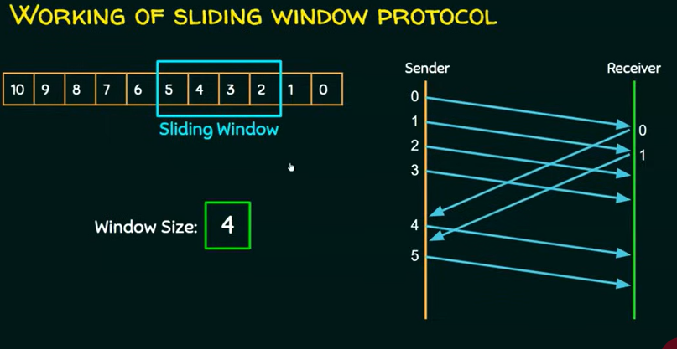

1. As a frame is acknowledged, window will slide towards to the other frame.
2. 